Due Date: 3/23/2023

Group 1

**Project 2: ETL, Crowdfunding**

**Names: Adal, Louie, Patricia, Raheleh and Rasha**

**Bootcamp: Data Analytics (GWU)**

**Data Analysis Tables**

1. **Category**

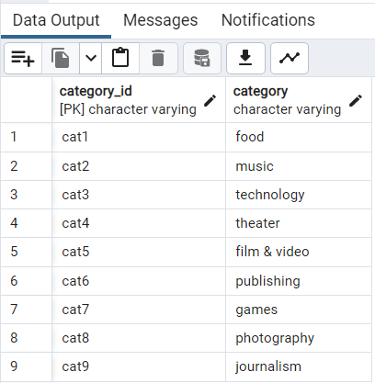

1. **Subcategory**

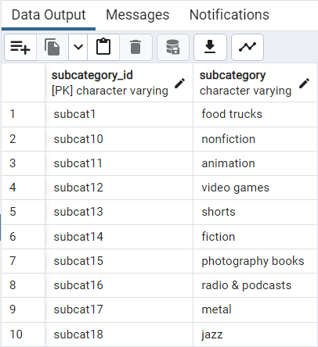

1. **Contacts:**

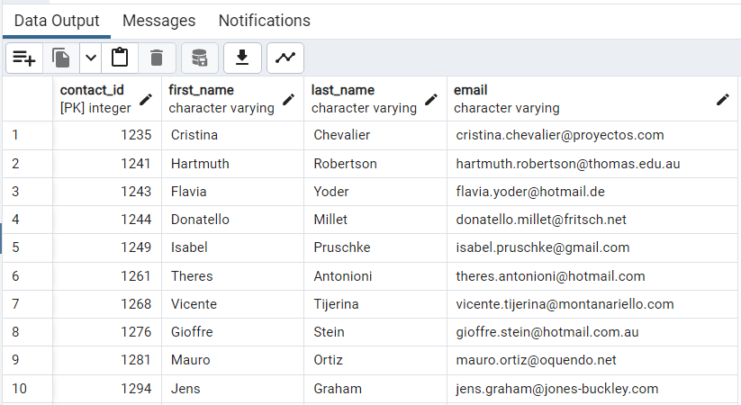

1. **Campaign**

